Integrating Soul & Role
A UCC Men’s Retreat

5:30 p.m. Friday, March 21 – 4:30 p.m. Saturday, March 22, 2014

The Landmark Resort • 4929 Landmark Dr. • Egg Harbor

You’re invited to join us for a UCC Men’s Retreat on Integrating Soul and Role.

The challenges and expectations facing men are both real and unique. In our work and personal lives, we find ourselves stretched by our responsibilities – and sometimes overwhelmed by them. We find it increasingly difficult to bring who we are into what we do.

This two-day retreat for UCC men will explore the soul of who we are as men and how we bring what we care most about into the many roles we play in our lives. What are the inner touchstones that make us who we are? How can be wholehearted in our work, relationships and family life?
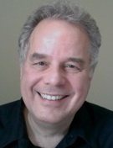
RETREAT LEADERSHIP

Albert Bellg, Ph.D. is a health psychologist, retreat leader, author, and facilitator-in-preparation with the Center for Courage & Renewal. A member of First Congo, he leads our Simply Mindful class and monthly gathering.

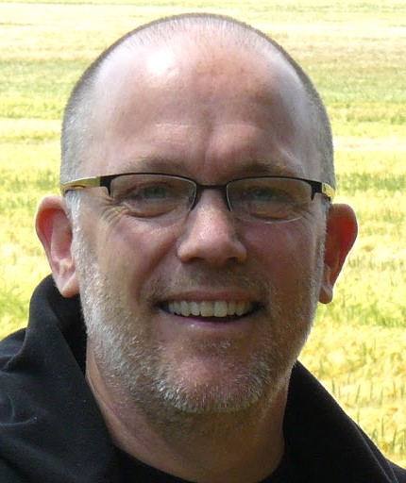
Rev. Winton Boyd is a facilitator with the Center for Courage & Renewal and guides retreats for a variety of professional groups throughout the Midwest and the nation. He is also the senior pastor at Orchard Ridge United Church of Christ in Madison.

WHAT WE’LL DO

Integrating Soul and Role will follow the guidelines developed by Parker J. Palmer (author of A Hidden Wholeness, Healing the Heart of Democracy, and other books) for Courage & Renewal retreats. We will create a confidential, safe men’s circle where we can:

- Explore the personal and spiritual touchstones that give us meaning and purpose.
- Learn ways to hold the tensions between our work and personal life without losing touch with what matters.
- Reconnect our spiritual life with what we do in our work, relationships, and family.
- Develop regular personal practices that revitalize and renew heart, mind, and spirit.

The retreat will include good food, physical and creative activities, opportunities to share stories, poetry and other readings, periods of silence, and time for journaling and individual reflection. During the retreat, we will create a trustworthy space and follow guidelines that respect each other’s experience.

SCHEDULE

Those who wish to carpool will meet at the church at 4:00 p.m. on Friday, March 21. Others can meet up at the Landmark Resort in Egg Harbor (approximately 90 minute drive from Appleton) at 5:30 p.m. The retreat will conclude by 4:30 p.m. on Saturday, March 22.

FOR MORE INFORMATION

Contact Albert Bellg at 920-996-0887 or abellg@att.net.

Integrating Soul & Role
A UCC Men’s Retreat

Friday, March 21 – Saturday, March 22, 2014
The Landmark Resort, Egg Harbor

REGISTRATION

Name __________________________________________________

Address ________________________________________________

City _________________________ State ______ Zip ____________

Phone _____________________ Email _______________________

Total (includes food and overnight lodging)

____ $185 (single room) ____ $145 (shared double room)

Please return your registration form to the church office as soon as possible. Payment is due by March 14.

